Practical 1:

Aim: Write a program to implement a simple web service that converts the temperature from Fahrenheit to Celsius and vice a versa.

Webform1.aspx

<%@ Page Language="C#" AutoEventWireup="true" CodeBehind="WebForm1.aspx.cs" Inherits="Temperature_Convertor.WebForm1" %>

<!DOCTYPE html>

<html xmlns="http://www.w3.org/1999/xhtml">

<head runat="server">

<title></title>

</head>

<body>

<form id="form1" runat="server">

<div>

<asp:Label ID="Label1" runat="server" Text="Farenheit To Celcius"></asp:Label>

<br />

Enter Temperature in Farenheit :&nbsp;&nbsp;&nbsp;&nbsp;&nbsp;

<asp:TextBox ID="TextBox1" runat="server"></asp:TextBox>

<br />

<br />

<asp:Button ID="Button1" runat="server" OnClick="Button1_Click" Text="ConvertTOCelcius" />

<br />

<br />

<asp:Label ID="lbl_result1" runat="server" Text="Label"></asp:Label>

<br />

<br />

Celcius To Farenheit<br />

Enter Temperature in Celcius:&nbsp;&nbsp;&nbsp;&nbsp;&nbsp;&nbsp;&nbsp;&nbsp;

<asp:TextBox ID="TextBox2" runat="server"></asp:TextBox>

<br />

<br />

<asp:Button ID="Button2" runat="server" OnClick="Button2_Click" Text="ConvertToFarenheit" />

<br />

<br />

<asp:Label ID="lbl_result2" runat="server" Text="Label"></asp:Label>

</div>

</form>

</body>

</html>

WebForm1.aspx.cs file

using System;

using System.Collections.Generic;

using System.Linq;

using System.Web;

using System.Web.UI;

using System.Web.UI.WebControls;

namespace Temperature_Convertor

{

public partial class WebForm1 : System.Web.UI.Page

{

protected void Page_Load(object sender, EventArgs e)

{

}

protected void Button1_Click(object sender, EventArgs e)

{

teperature t = new teperature();

lbl_result1.Text = t.FarenheitToCelcius(Double.Parse(TextBox1.Text)).ToString();

}

protected void Button2_Click(object sender, EventArgs e)

{

teperature t1 = new teperature();

lbl_result2.Text = t1.CelciusToFarenheit(Double.Parse(TextBox2.Text)).ToString();

}

}

}

Temperature.asmx file

using System;

using System.Collections.Generic;

using System.Linq;

using System.Web;

using System.Web.Services;

namespace Temperature_Convertor

{

/// <summary>

/// Summary description for teperature

/// </summary>

[WebService(Namespace = "http://tempuri.org/")]

[WebServiceBinding(ConformsTo = WsiProfiles.BasicProfile1_1)]

[System.ComponentModel.ToolboxItem(false)]

// To allow this Web Service to be called from script, using ASP.NET AJAX, uncomment the following line.

// [System.Web.Script.Services.ScriptService]

public class teperature : System.Web.Services.WebService

{

[WebMethod]

public string HelloWorld()

{

return "Hello World";

}

[WebMethod]

public double FarenheitToCelcius(double fahr)

{

return ((fahr - 32) / 9 * 5);

}

[WebMethod]

public double CelciusToFarenheit(double cel)

{

return ((cel*9)/5)+32;

}

}

}

OUTPUT:

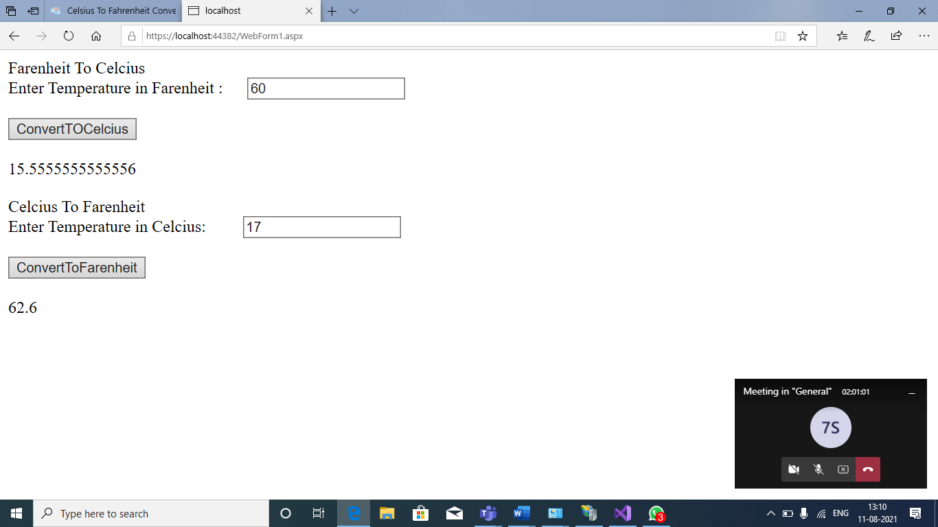

Practical 2:

Aim: Write a program to implement the operation can receive request and will return a response in two ways.

1. One-Way operation
2. Two- Way opearation

Service1.svc.cs

using System;

using System.Collections.Generic;

using System.Linq;

using System.Runtime.Serialization;

using System.ServiceModel;

using System.ServiceModel.Web;

using System.Text;

namespace WcfPractical2

{

// NOTE: You can use the "Rename" command on the "Refactor" menu to change the class name "Service1" in code, svc and config file together.

// NOTE: In order to launch WCF Test Client for testing this service, please select Service1.svc or Service1.svc.cs at the Solution Explorer and start debugging.

public class Service1 : IService1

{

public string GetData(int value)

{

return string.Format("You entered: {0}", value);

}

public void subtract(double n1, double n2)

{

double result = n1 - n2;

Console.WriteLine("Subtract({0},{1})={2}",n1,n2,result);

}

public double add(double n1, double n2)

{

double result = n1 + n2;

return result;

}

public void multiply(double n1, double n2)

{

double result = n1 * n2;

Console.WriteLine("multiply({0},{1})={2}", n1, n2, result);

}

public void divide(double n1, double n2)

{

double result = n1 / n2;

Console.WriteLine("divide({0},{1})={2}", n1, n2, result);

}

public String SayHello(string name)

{

Console.WriteLine("SayHello({0})", name);

return "Hello " + name;

}

public CompositeType GetDataUsingDataContract(CompositeType composite)

{

if (composite == null)

{

throw new ArgumentNullException("composite");

}

if (composite.BoolValue)

{

composite.StringValue += "Suffix";

}

return composite;

}

}

}

IService1.cs

using System;

using System.Collections.Generic;

using System.Linq;

using System.Runtime.Serialization;

using System.ServiceModel;

using System.ServiceModel.Web;

using System.Text;

namespace WcfPractical2

{

// NOTE: You can use the "Rename" command on the "Refactor" menu to change the interface name "IService1" in both code and config file together.

[ServiceContract]

public interface IService1

{

[OperationContract]

string GetData(int value);

[OperationContract]

CompositeType GetDataUsingDataContract(CompositeType composite);

// TODO: Add your service operations here

[OperationContract(IsOneWay = true)]

void subtract(double n1, double n2);

[OperationContract(IsOneWay = true)]

void multiply(double n1, double n2);

[OperationContract(IsOneWay = true)]

void divide(double n1, double n2);

[OperationContract]

string SayHello(string name);

[OperationContract]

double add(double n1, double n2);

}

// Use a data contract as illustrated in the sample below to add composite types to service operations.

[DataContract]

public class CompositeType

{

bool boolValue = true;

string stringValue = "Hello ";

[DataMember]

public bool BoolValue

{

get { return boolValue; }

set { boolValue = value; }

}

[DataMember]

public string StringValue

{

get { return stringValue; }

set { stringValue = value; }

}

}

}

Output:

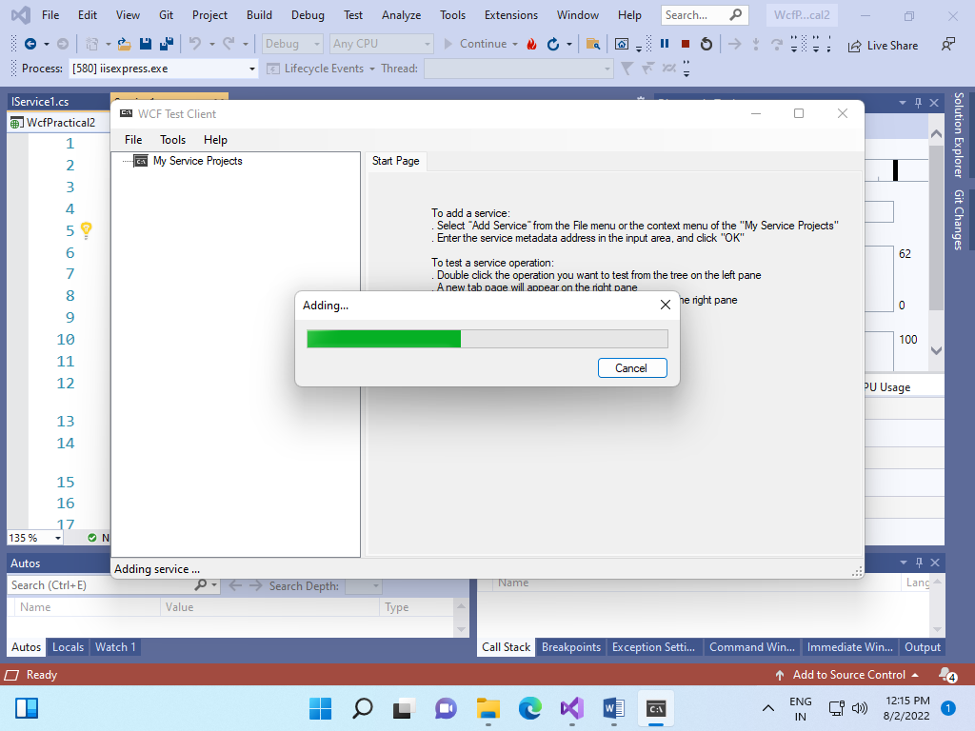

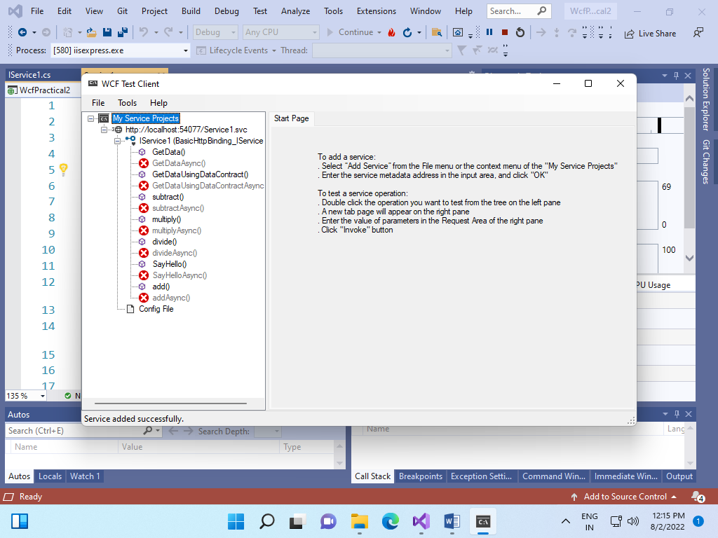

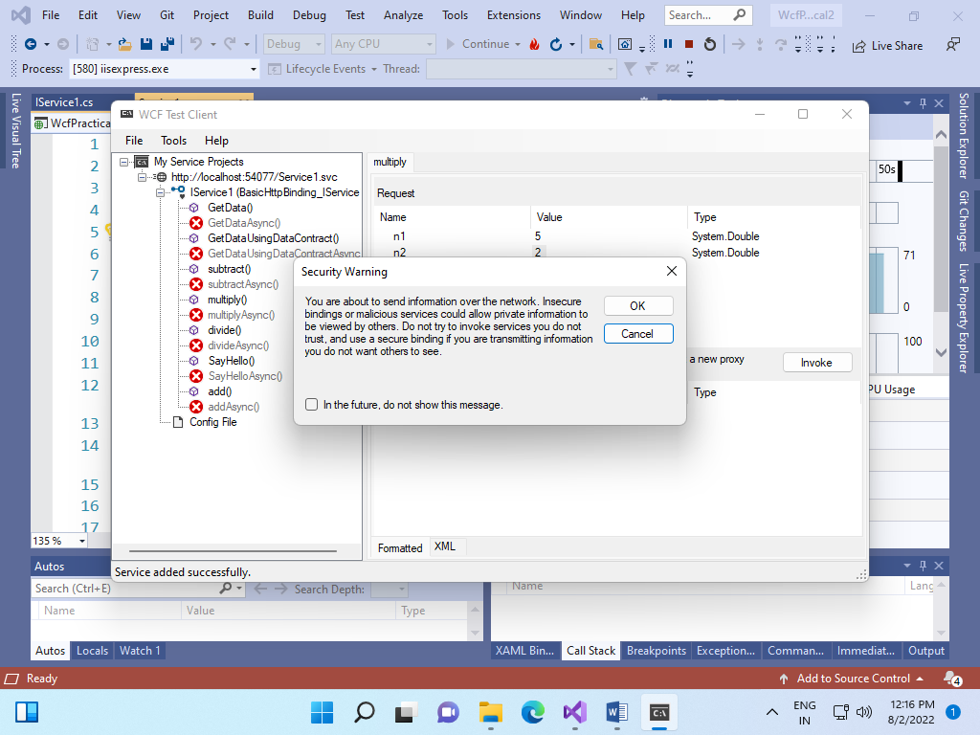

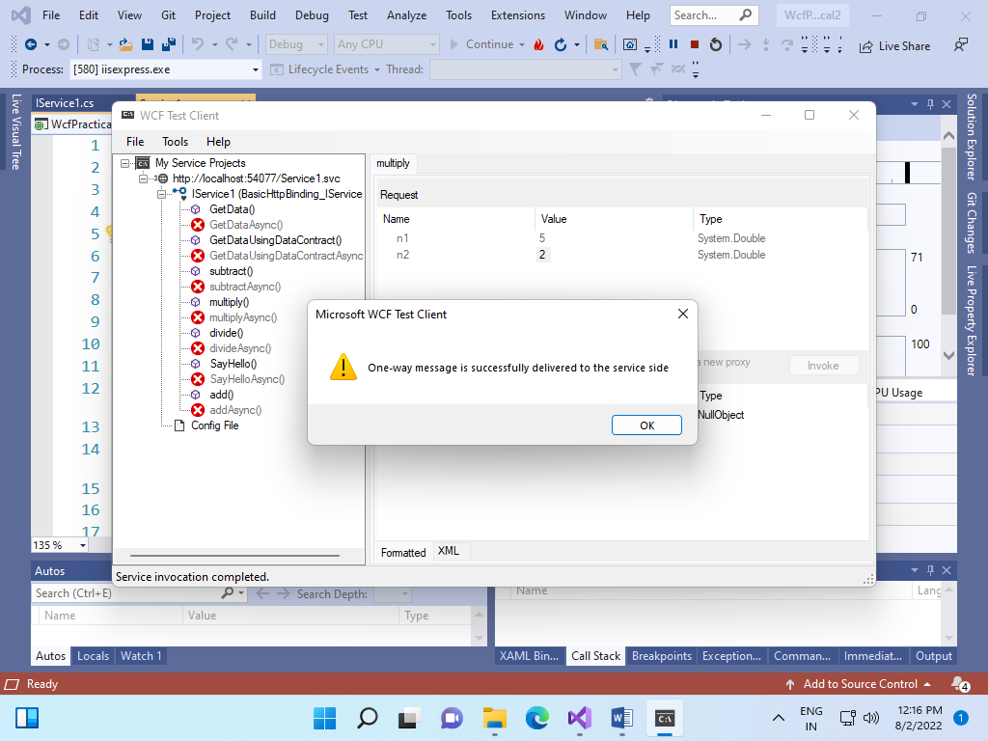

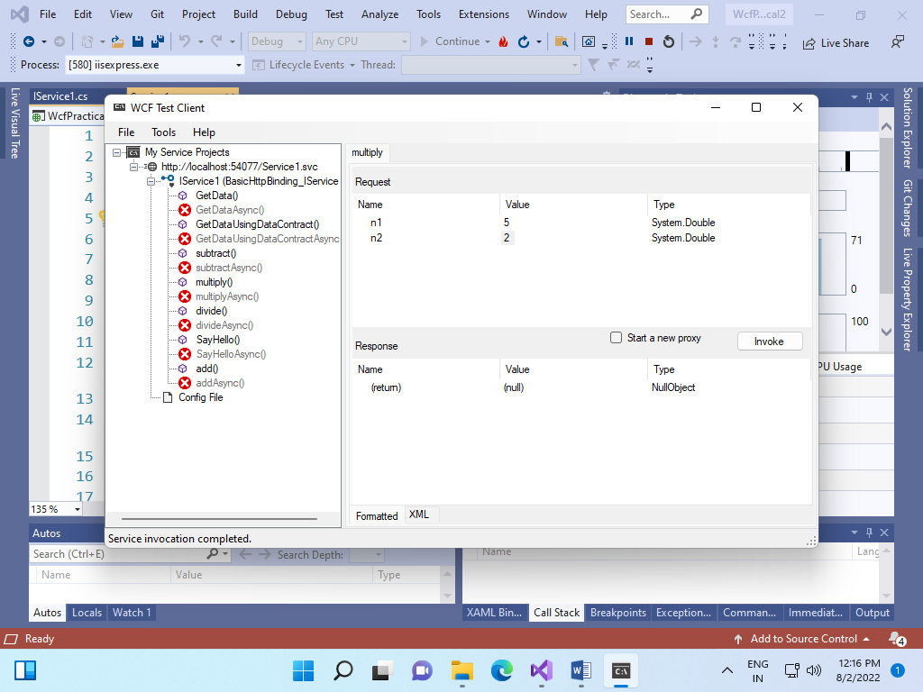

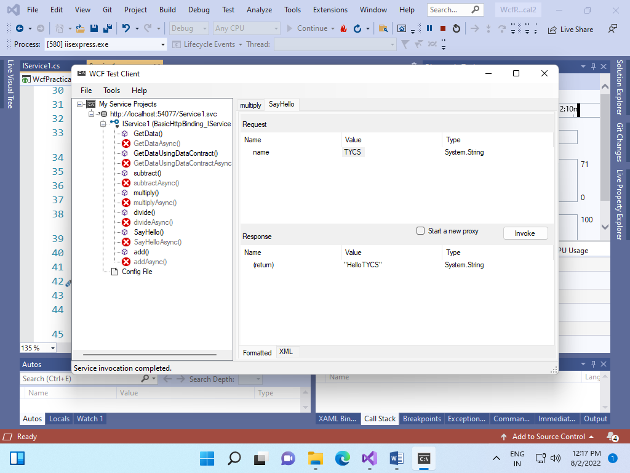

Practical 3: Develop client which consumes web services developed in different platform.

STEP 1: CREATE AN EMPTY WEB APPLICATION IN ASP.NET.

STEP 2: AFTER THE CREATION OF WEB APPICATION ADD NEW ITEM TO THE WEB APPLICATION BY RIGHT CLICKING ON SOLUTION

AND ADD NEW ITEM.

STEP 3: SELECT WEB SERVICE(ASMX) FILE.

STEP 4: RENAME THE FILE AS Opearation.asmx.

Opeartion.asmx

using System;

using System.Collections.Generic;

using System.Linq;

using System.Web;

using System.Web.Services;

namespace ClientConsumer

{

/// <summary>

/// Summary description for Operation

/// </summary>

[WebService(Namespace = "http://tempuri.org/")]

[WebServiceBinding(ConformsTo = WsiProfiles.BasicProfile1_1)]

[System.ComponentModel.ToolboxItem(false)]

// To allow this Web Service to be called from script, using ASP.NET AJAX, uncomment the following line.

// [System.Web.Script.Services.ScriptService]

public class Operation : System.Web.Services.WebService

{

[WebMethod]

public double Add(double a,double b)

{

double sum = a + b;

return sum;

}

[WebMethod]

public double Multi(double a, double b)

{

double product = a * b;

return product;

}

}

}

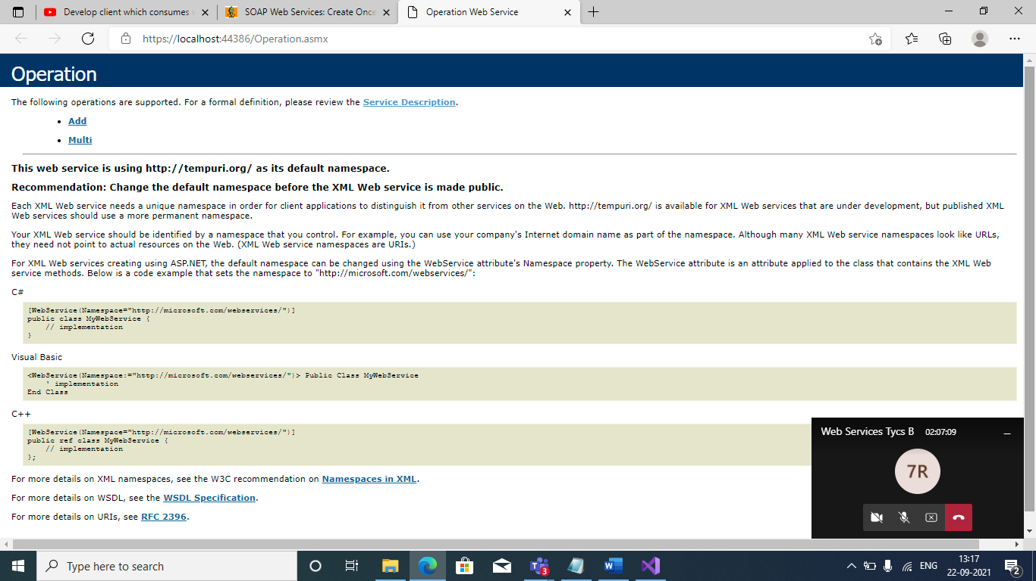

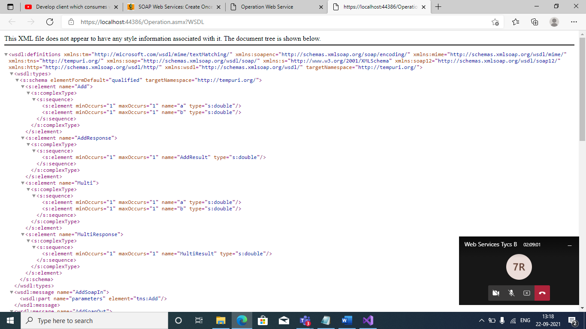

STEP 5: OPEN NETBEANS IDE AND CREATE NEW JAVA WEB APPLICATION.

STEP 6: EXPAND THE PROJECT AND RIGHT CLICK ON PROJECT NAME.

STEP 7: SELECT WEB SERVICE CLIENT AND CLICK ON NEXT.

STEP 8: IN WSDL AND CLIENT LOCATION WINDOW SELECT WSDL URL RADIO BUTTON. COPY AND PASTE THE WSDL FILE URL.

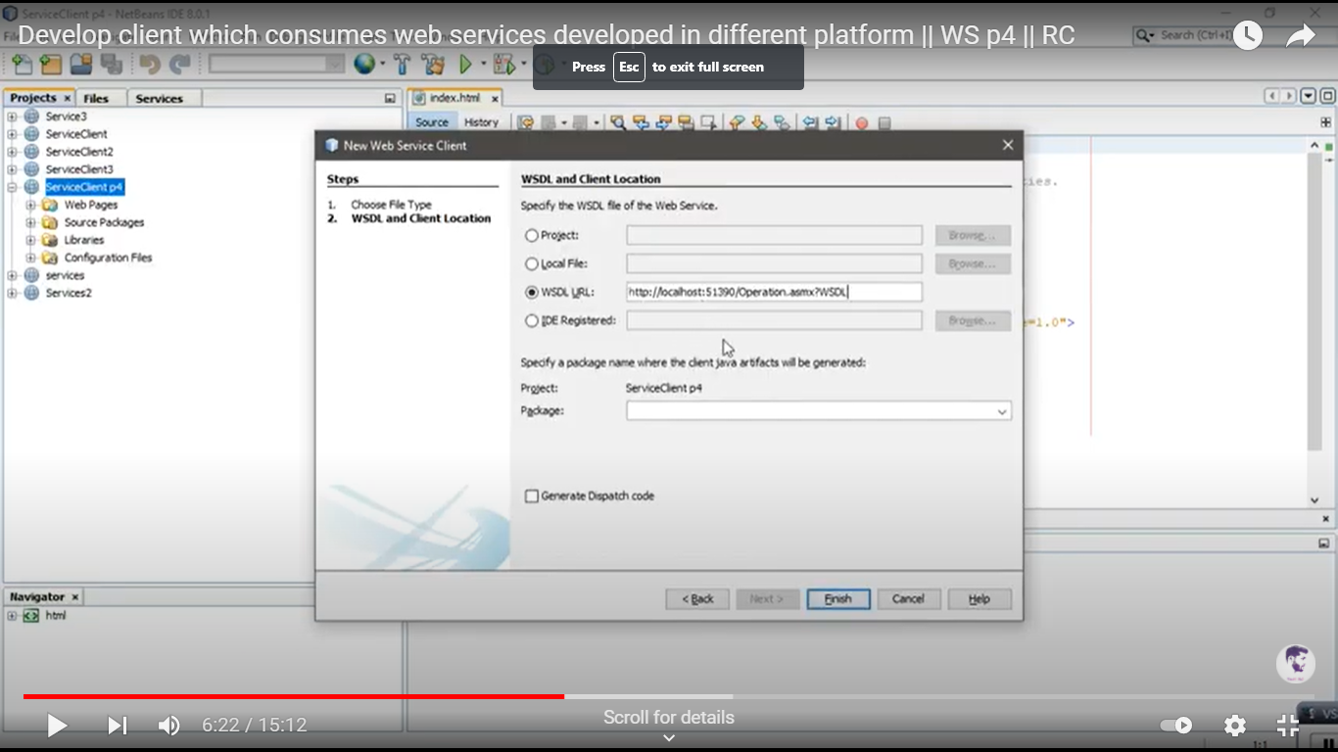

STEP 9: SPECIFY PACKAGE AND CLICK ON FINISH. IN WEB SERVICE REFERNCES OPERATION IS VISIBLE.

CLICK ON OPERATIONSOAP. THE WEB METHODS FROM .NET APPLICATION ARE VISIBLE.

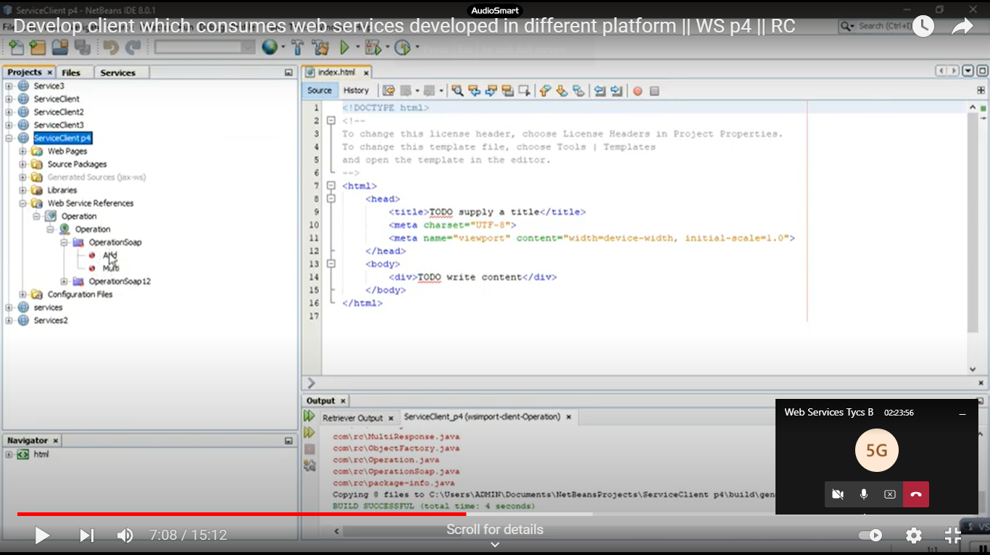

STEP 10: CREATE 2 JSP FILES BY RIGHT CLICKING ON SOURCE PACKAGES OF YOUR PROJECT. NAME THEM AS ADDITION.JSP AND MULTIPLICATION.JSP.

ADDITION.JSP

Right click in the body tag of the page.

Select Web service client resources and select -> call *web service operation*.

*Select operation to invoke* window appears.

From *OpearationSoap* select *Add.*

Code of Add method will be added automatically. Do the necessary changes in the file.

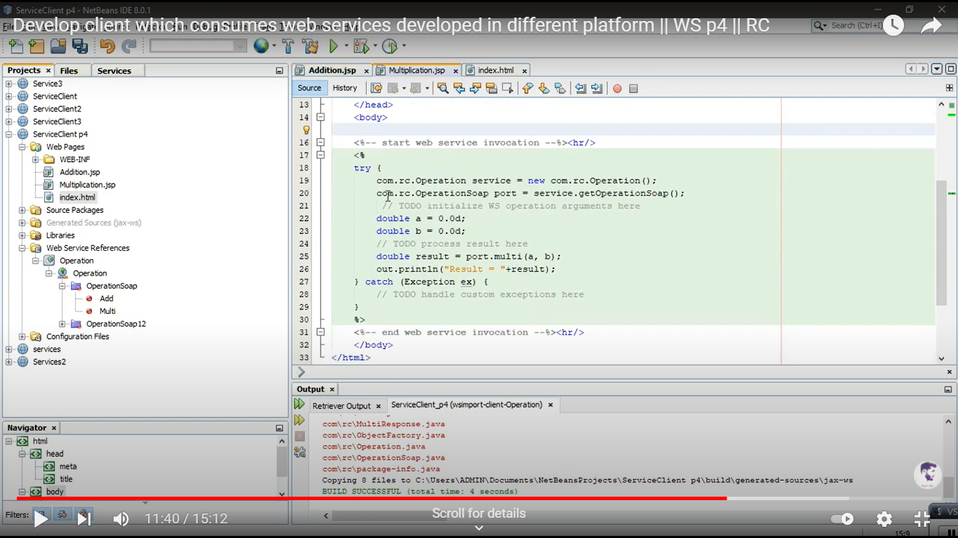

Multiplication.jsp

Right click in the body tag of the page.

Select Web service client resources and select -> call *web service operation*.

*Select operation to invoke* window appears.

From *OpearationSoap* select *Add.*

Code of Multi method will be added automatically. Do the necessary changes in the file.

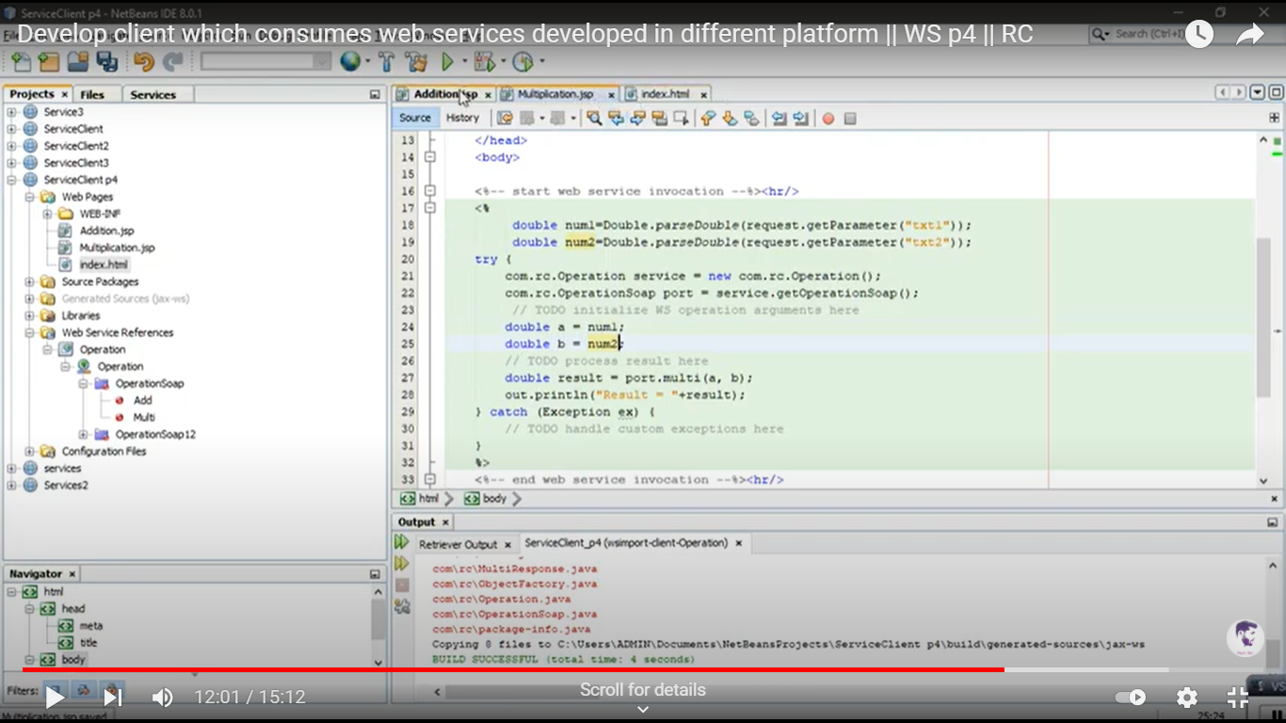

STEP 11:

Now create index.HTML File.

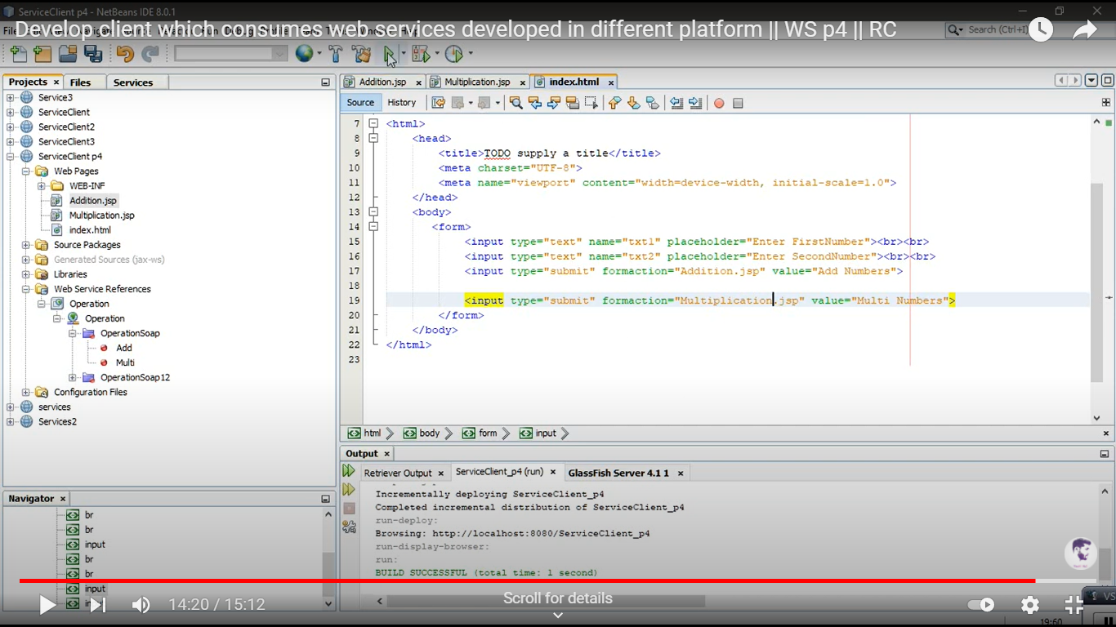

OUTPUT:

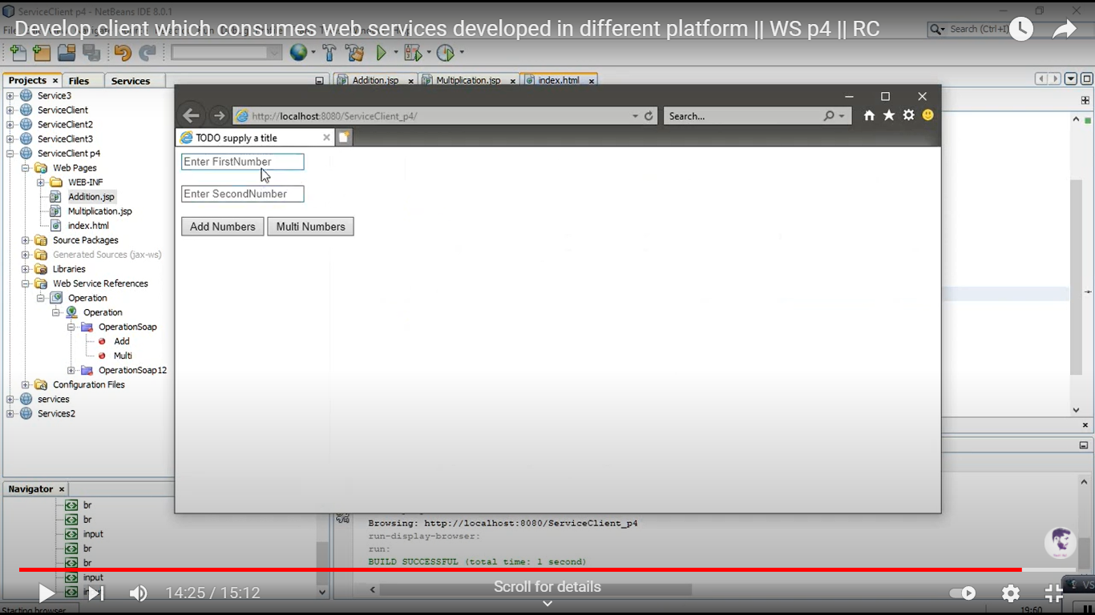

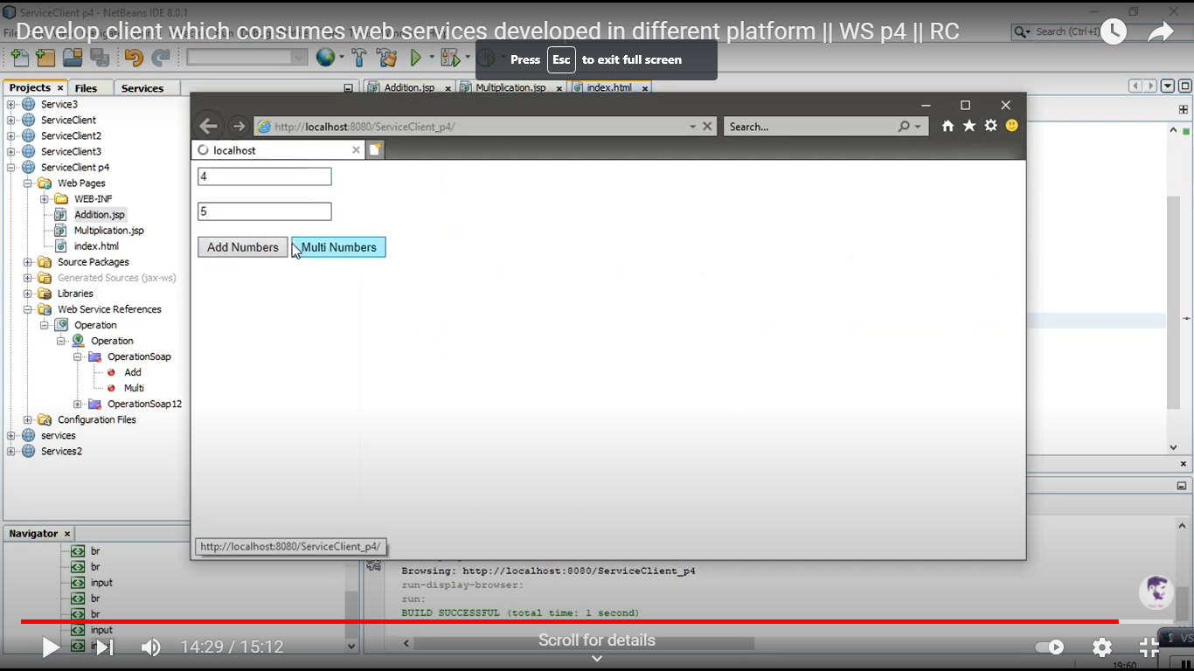

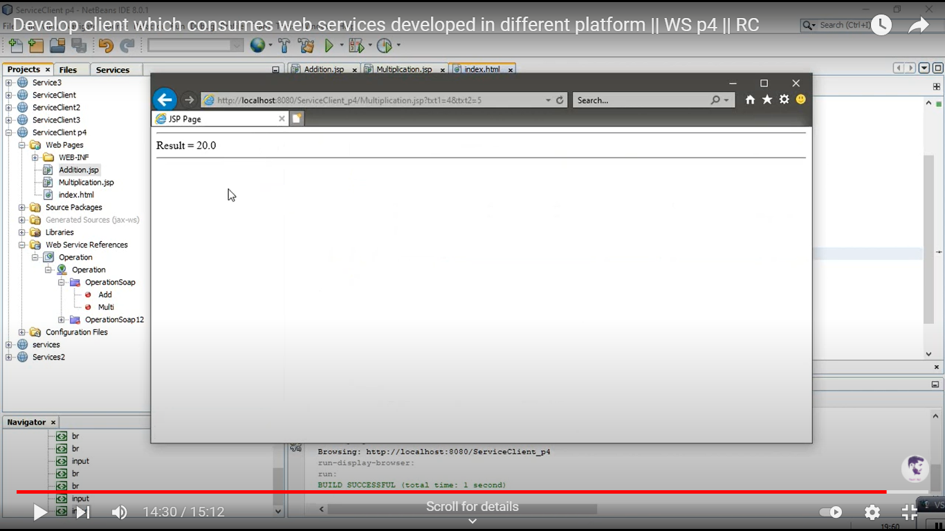

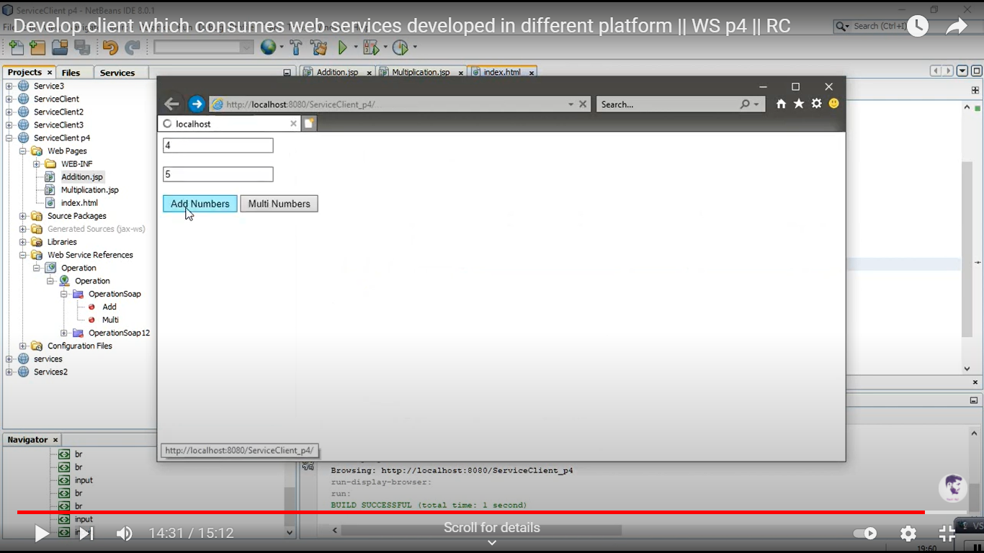

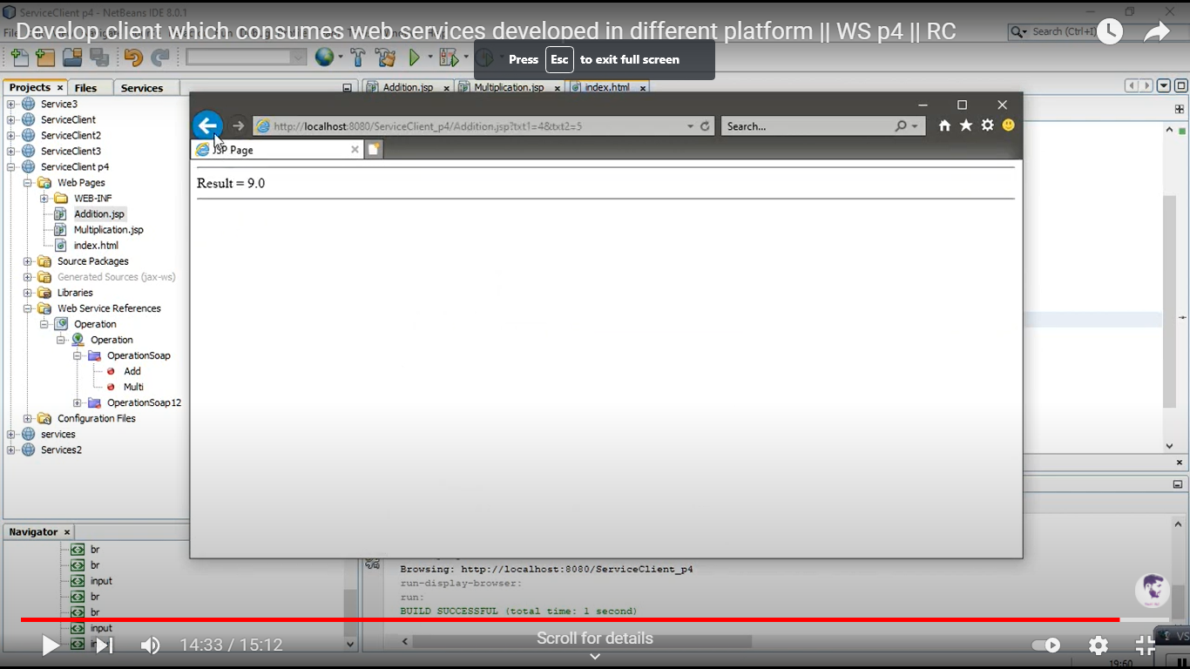

Practical 4

Aim: Write a program to implement business UDDI Registry entry.

**Write a program to implement business UDDI Registry entry**

<businessEntity businessKey = "uuid:C0E6D5A8-C446-4f01-99DA-70E212685A40"

operator = "http://www.ibm.com" authorizedName = "John Doe">

<name>Acme Company</name>

<description>

We create cool Web services

</description>

<contacts>

<contact useType = "general info">

<description>General Information</description>

<personName>John Doe</personName>

<phone>(123) 123-1234</phone>

<email>jdoe@acme.com</email>

</contact>

</contacts>

<businessServices>

...

</businessServices>

<identifierBag>

<keyedReference tModelKey = "UUID:8609C81E-EE1F-4D5A-B202-3EB13AD01823"

name = "D-U-N-S" value = "123456789" />

</identifierBag>

<categoryBag>

<keyedReference tModelKey = "UUID:C0B9FE13-179F-413D-8A5B-5004DB8E5BB2"

name = "NAICS" value = "111336" />

</categoryBag>

</businessEntity>

Creating Registry

After obtaining an authentication token from one of the operators Microsoft, for example the XYZ.com developers decide what information to publish to the registry and use one of the UDDI tools provided by Microsoft.

POST /save_business HTTP/1.1

Host: www.XYZ.com

Content-Type: text/xml; charset = "utf-8"

Content-Length: nnnn

SOAPAction: "save_business"

<?xml version = "1.0" encoding = "UTF-8" ?>

<Envelope xmlns = "http://schemas/xmlsoap.org/soap/envelope/">

<Body>

<save_business generic = "2.0" xmlns = "urn:uddi-org:api_v2">

<businessKey = "">

</businessKey>

<name>

XYZ, Pvt Ltd.

</name>

<description>

Company is involved in giving Stat-of-the-art....

</description>

<identifierBag> ... </identifierBag>

...

</save_business>

</Body>

</ Envelope>

## Retrieving Information

After XYZ Company has updated its UDDI entry with the relevant information, companies that want to become XYZ distributors can look up contact information in the UDDI registry and obtain the service descriptions and the access points for the two Web services that XYZ.com publishes for online order entry.

POST /get_businessDetail HTTP/1.1

Host: www.XYZ.com

Content-Type: text/xml; charset = "utf-8"

Content-Length: nnnn

SOAPAction: "get_businessDetail"

<?xml version = "1.0" encoding = "UTF-8" ?>

<Envelope xmlns = "http://schemas/xmlsoap.org/soap/envelope/">

<Body>

<get_businessDetail generic = "2.0" xmlns = "urn:uddi-org:api_v2">

<businessKey = "C90D731D-772HSH-4130-9DE3-5303371170C2">

</businessKey>

</get_businessDetail>

</Body>

</Envelope>

Practical 5: Write a JAX-WS web service to perform the following operations. Define a Servlet or JSP that consumes the web service.

1. Create a Web application in Netbeans IDE.
2. Now select web application name and right click and select new -> web service. Give name and select Implement web service by stateless session beans.
3. Select NewWebService and right click and select add operation. Create method add with two parameters.
4. Now test your web service and deploy it.
5. Now consume your web service.

Create new project ->java web ->new web application.

1. Now add new web Service client by right clicking on web application name and add project url for web reference.
2. Now add new servlet.
3. Drag and drop add method to java code.

Code for java file:

import java.io.IOException;

import java.io.PrintWriter;

import javax.servlet.ServletException;

import javax.servlet.annotation.WebServlet;

import javax.servlet.http.HttpServlet;

import javax.servlet.http.HttpServletRequest;

import javax.servlet.http.HttpServletResponse;

import javax.xml.ws.WebServiceRef;

import com.add.NewWebService_Service;

/**

*

* @author lab503

*/

@WebServlet(urlPatterns = {"/addition"})

public class addition extends HttpServlet {

@WebServiceRef(wsdlLocation = "WEB-INF/wsdl/localhost_8080/NewWebService/NewWebService.wsdl")

private NewWebService_Service service;

/**

* Processes requests for both HTTP <code>GET</code> and <code>POST</code>

* methods.

*

* @param request servlet request

* @param response servlet response

* @throws ServletException if a servlet-specific error occurs

* @throws IOException if an I/O error occurs

*/

protected void processRequest(HttpServletRequest request, HttpServletResponse response)

throws ServletException, IOException {

response.setContentType("text/html;charset=UTF-8");

try (PrintWriter out = response.getWriter()) {

/* TODO output your page here. You may use following sample code. */

out.println("<!DOCTYPE html>");

out.println("<html>");

out.println("<head>");

out.println("<title>Servlet addition</title>");

out.println("</head>");

out.println("<body>");

out.println("<form>");

out.println("Enter first number :<input type ='text' name='n1'>");

out.println("Enter second number :<input type ='text' name='n2'>");

out.println("<input type='submit' value='add'/> </form>");

out.println("<h1>Addition of two numbers is "+ add(Integer.parseInt(request.getParameter("n1")),Integer.parseInt(request.getParameter("n2"))));

out.println("</body>");

out.println("</html>");

}

}

// <editor-fold defaultstate="collapsed" desc="HttpServlet methods. Click on the + sign on the left to edit the code.">

/**

* Handles the HTTP <code>GET</code> method.

*

* @param request servlet request

* @param response servlet response

* @throws ServletException if a servlet-specific error occurs

* @throws IOException if an I/O error occurs

*/

@Override

protected void doGet(HttpServletRequest request, HttpServletResponse response)

throws ServletException, IOException {

processRequest(request, response);

}

/**

* Handles the HTTP <code>POST</code> method.

*

* @param request servlet request

* @param response servlet response

* @throws ServletException if a servlet-specific error occurs

* @throws IOException if an I/O error occurs

*/

@Override

protected void doPost(HttpServletRequest request, HttpServletResponse response)

throws ServletException, IOException {

processRequest(request, response);

}

/**

* Returns a short description of the servlet.

*

* @return a String containing servlet description

*/

@Override

public String getServletInfo() {

return "Short description";

}// </editor-fold>

private int add(int n1, int n2) {

// Note that the injected javax.xml.ws.Service reference as well as port objects are not thread safe.

// If the calling of port operations may lead to race condition some synchronization is required.

com.add.NewWebService port = service.getNewWebServicePort();

return port.add(n1, n2);

}

}

Output:

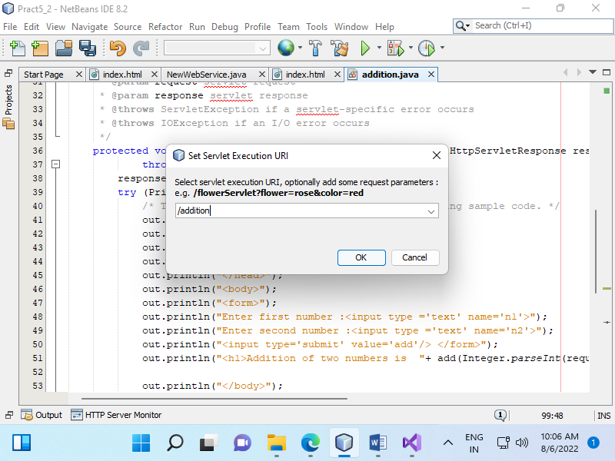

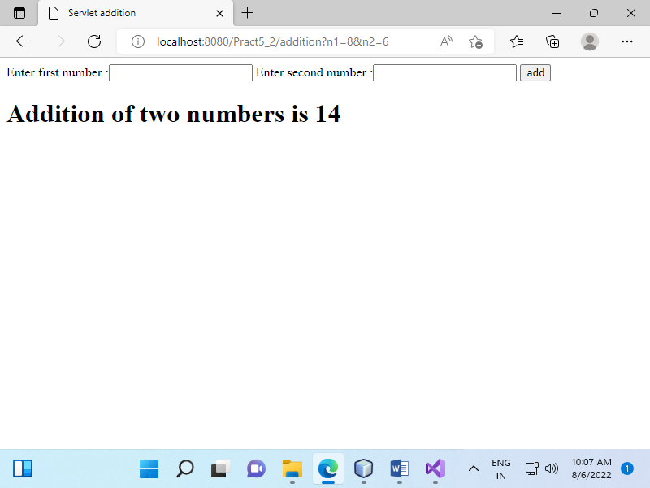

Practical 6:

Aim: Define a web service method that returns the contents of a database in a JSON string. The contents should be displayed in a tabular format.

1. Click on Window menu and click on **Projects, Files** & **Services** to open it.

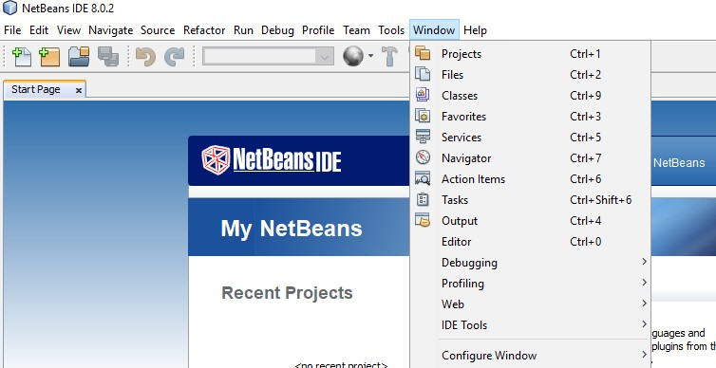

1. **Right click on Java DB** and then **click on Start Server** to start the server .

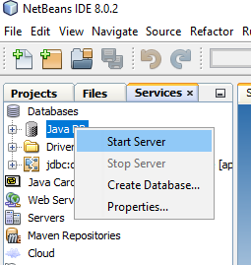

1. Now expand Java DB and **right click on sample** and then **click on connect** to connect the sample database with server.

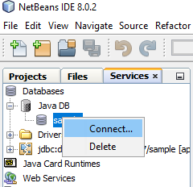

1. Now we are going to create a table in default database **sample**. **Right click on Table -> Create Table**

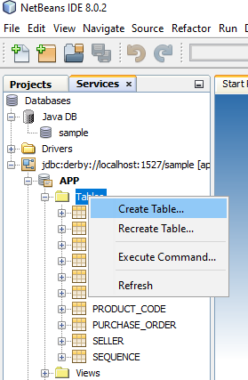

1. Give **table name** as **FRIENDS**.

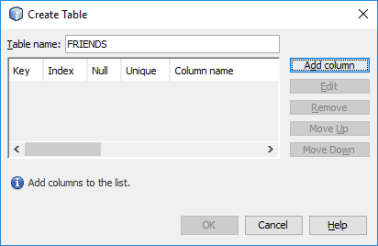

1. Now **click on Add column** button **to add columns** in table.

Enter details as in below pic and **select Primary key**. After that **click on OK**

button.

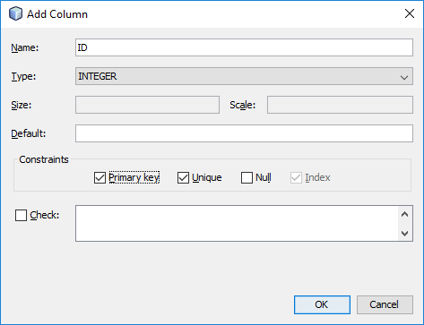

1. Now **add second column** with following detail. But **don’t select primary** and click on OK button.

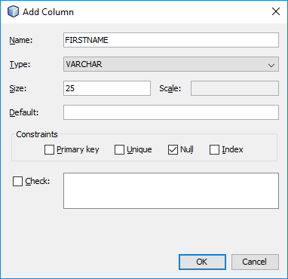

1. Now **click on OK** button.

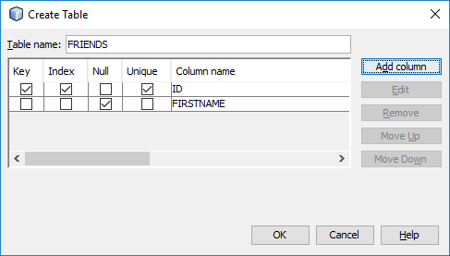

1. Now you can see a table with name **FRIENDS** in the table.

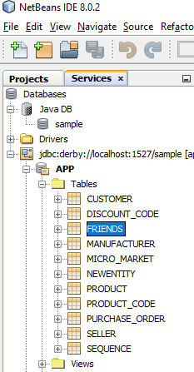

1. **Right click on FRIENDS to view and add records** into it.

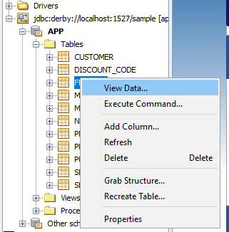

1. Now **click on the leftmost icon in second panel to insert some record**.

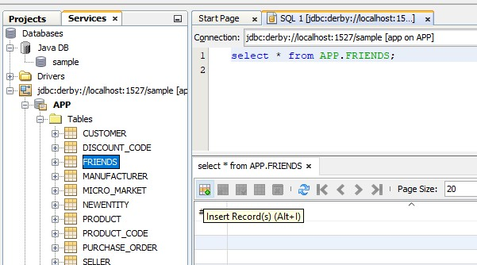

1. **Insert a record** and then **click on Add Row button to insert more record**. After that **click on OK button** to finish.

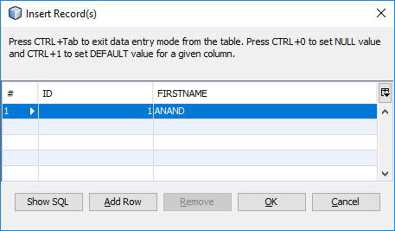

1. As you can see, I have entered 7 records.

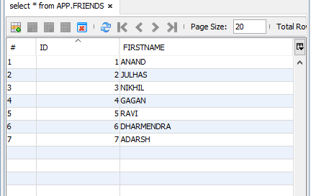

1. Now **create a web application** with name **Server**. After that **click on Next and then Finish** button.

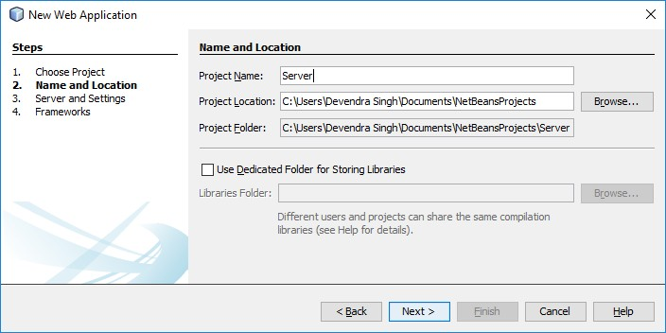

1. Now **create a RESTful Web Service from Database by right click on project**

name.

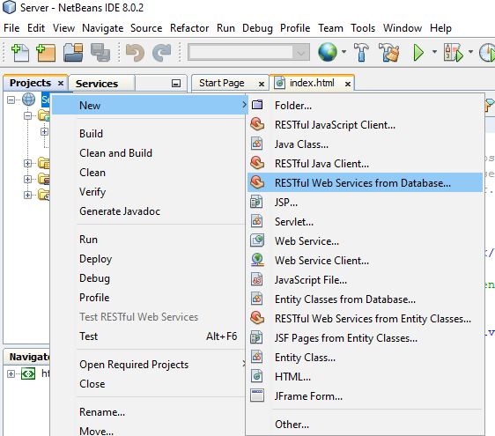

1. Choose **Data Source jdbc/sample**.

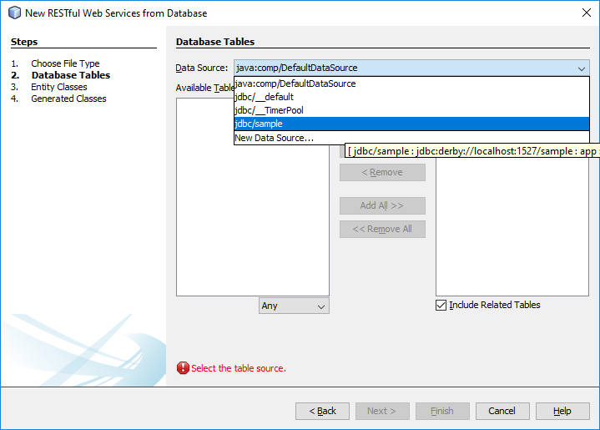

1. Now **select FRIENDS** and **click on Add button**. After that **click on Next** button.

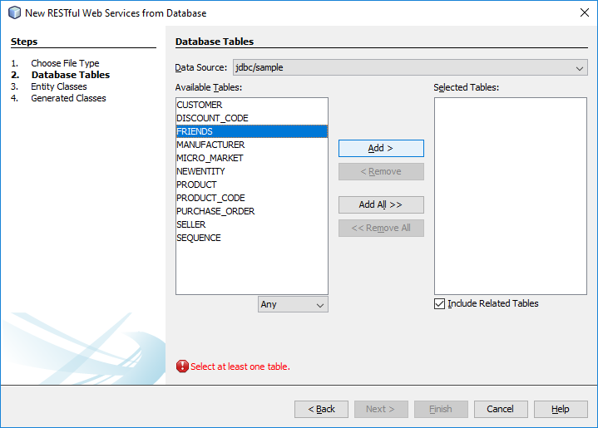

1. **Enter Package name** as **com.kk** and **click on Next** button and **then Finish**.

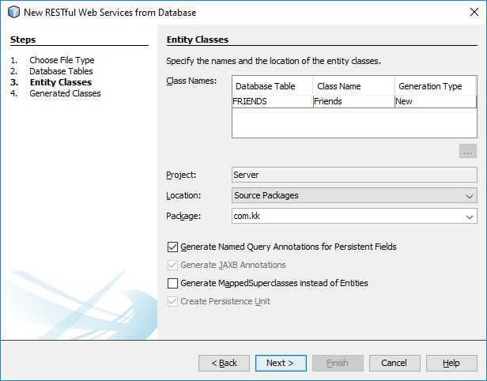

1. Now **open selected file by double click** on it.

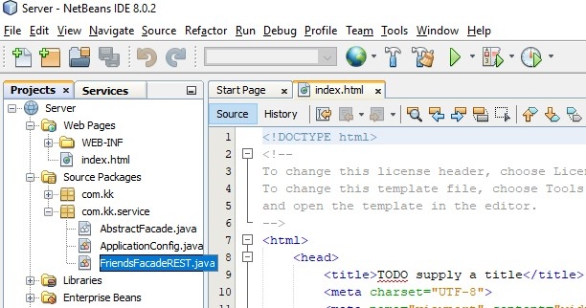

1. Now **remove the selected part from every method in this file**. So that it will communicate only in JSON format. You can also use methods to convert it. But this is easiest method.

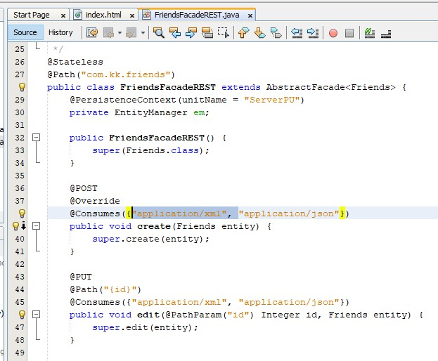

1. After that **right click on project name and Deploy** it.

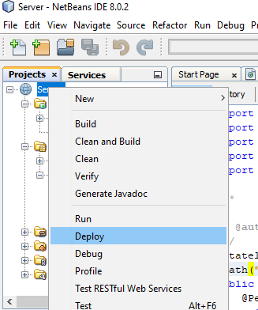

1. Now **create one more Web Application** as **Client**. After that **click on Next** and then **Finish** button.

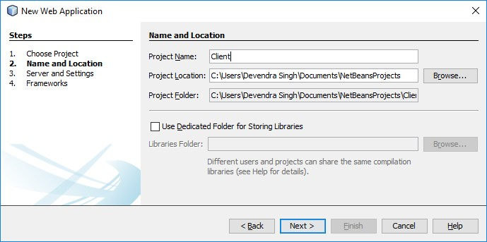

1. Now **open the index.html file of Client project** and **add the following code in between HEAD tag**.

<style>

table {

font-family: arial, sans-serif; border-collapse: collapse;

}

td, th {

border: 1px solid #000000; text-align: center; padding: 8px;

}

</style>

<script>

var request = new XMLHttpRequest(); request.open('GET',

**'**http://localhost:8080/Server/webresources/com.kk.friends/**', true); request.onload = function () {**

// begin accessing JSON data here var data = JSON.parse(this.response);

for (var i = 0; i < data.length; i++) {

var table = document.getElementById("myTable"); var row = table.insertRow();

var cell1 = row.insertCell(0); var cell2 = row.insertCell(1); cell1.innerHTML = data[i].id;

cell2.innerHTML = data[i].firstname;

}

};

request.send();

</script>

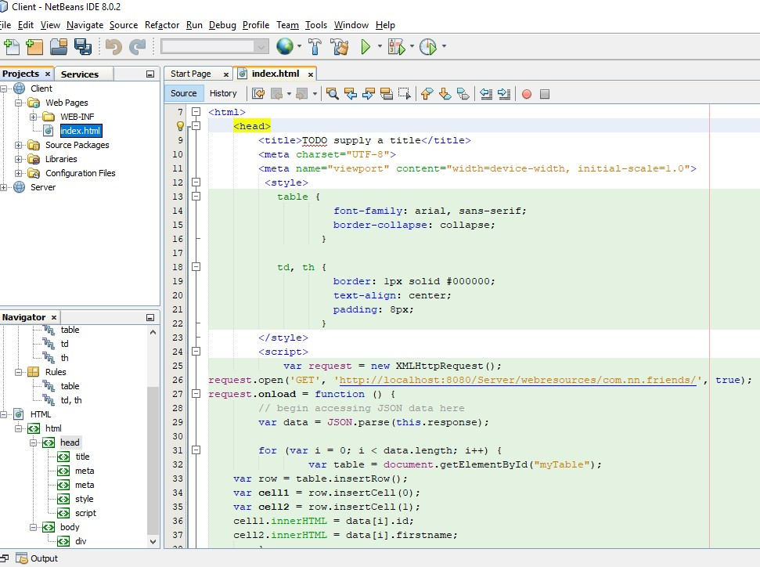

1. **Replace the content of body** tag **with following code**.

<table id="myTable">

<tr>

<th> ID</th>

<th>NAME</th>

</tr>

</table>

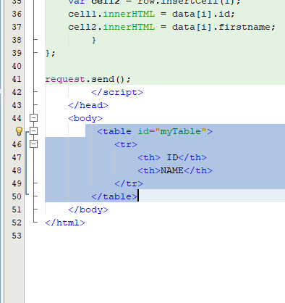

1. Now **run** the **Client** Web Application.

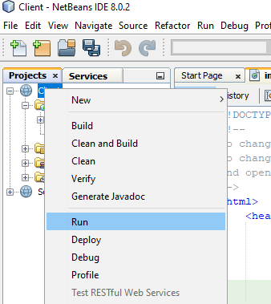

1. A window will open in browser which represents a data in tabular format. These **data are the records entered in FRIEND table**.

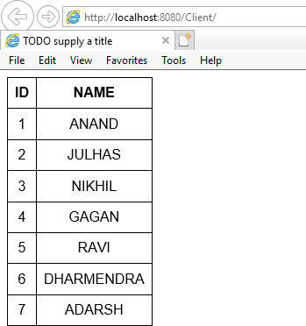

Practical 7:

Aim: Define a RESTFUL web service that accepts the details to be stored in a database and performs CRUD operation.

1. Click on Window menu and click on Projects, Files & Services to open it.
2. Right click on Java DB and then click on Start Server to start the server.
3. Now expand Java DB and right click on sample and then click on connect to connect the sample database with server.
4. Now create a web application with the name CRUD_Operation.
5. Create an entity class. Right click on project name -> New -> Entity Class.
6. A window will appear.

Class Name -> Employee

Package Name -> com.emp

1. Click on Finish.

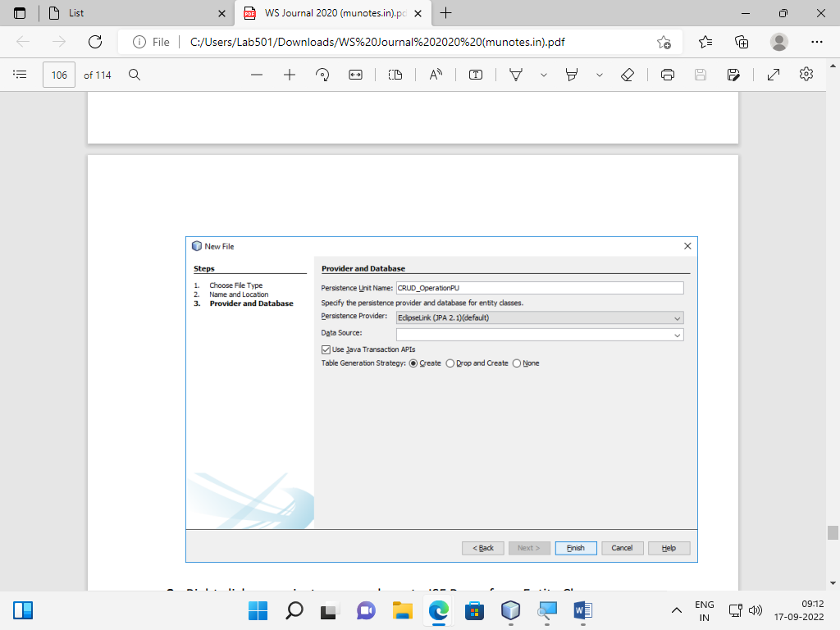

1. Right click on project name and create JSF Pages from Entity Classes. Right click on project name -> New -> JSF Pages from Entity Classes
2. Select com.emp.Employee and click on Add button and then Next button on below.
3. A window like below will appear on the screen. Enter the data into that window as entered in below pic and click on Next button.

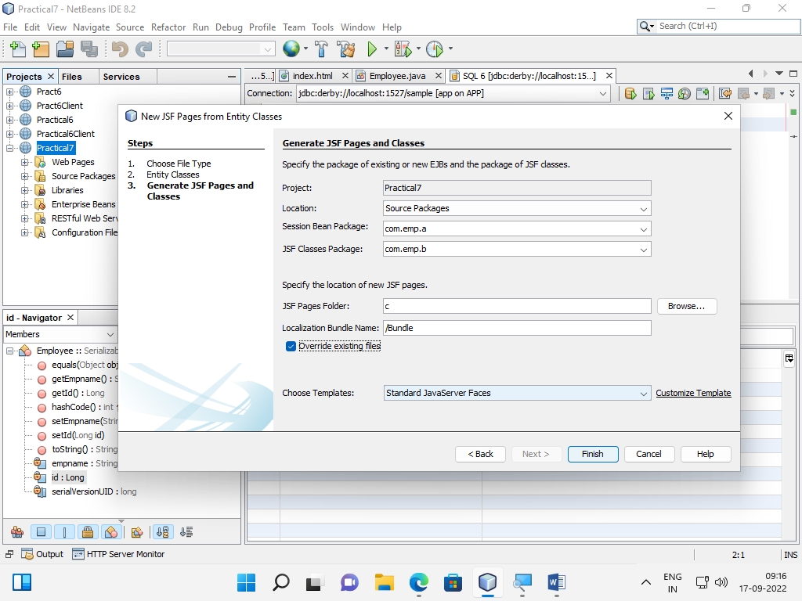

1. Now click on Finish.
2. Right click on project name and create RESTful Web Services from Entity Classes. Right click on project name -> New -> RESTful Web Services from Entity Classes.
3. Repeat step 9 and then it will go on next page. Then enter the com.emp.service in Resource Package and then click on Finish button.
4. Now open Employee.java file under com.emp package.
5. In this file at line number 24, do the right click and select Insert Code.
6. A new list will appear. Click on Add Property.
7. A new window will open. Enter name as EmpName. Click on OK button. Actually we are setting getter and setter method for EmpName.
8. Now right click on web application name and Deploy it.
9. Now right click on project name and run it.

Output:

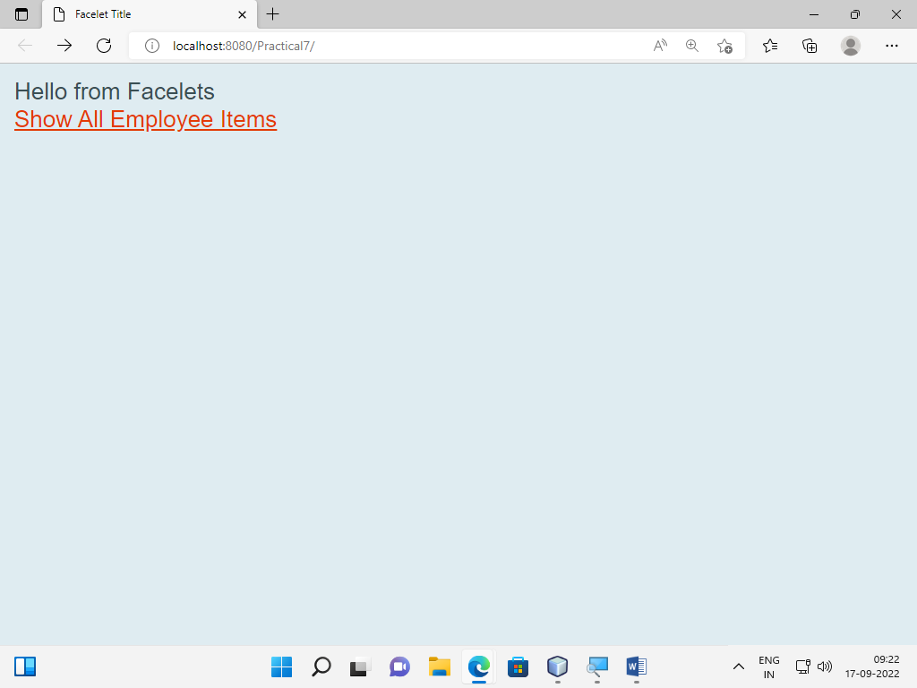

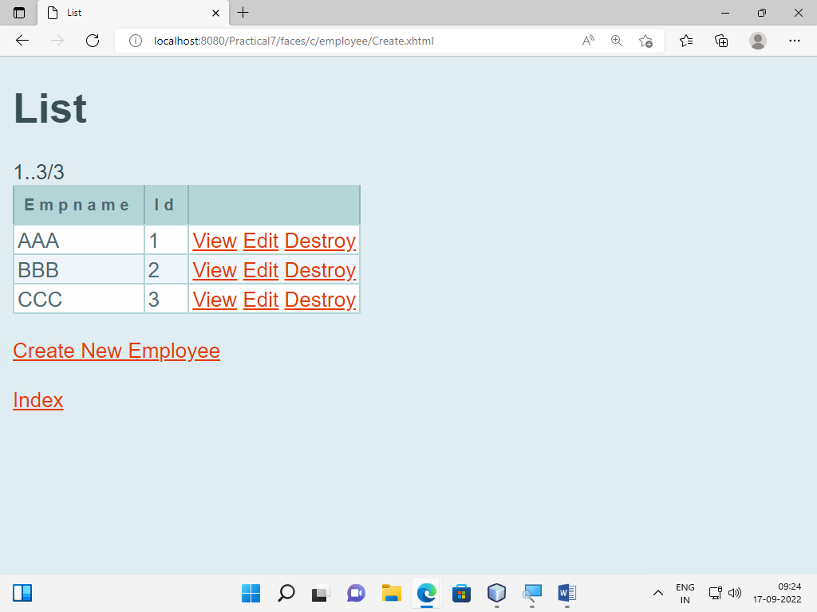

Practical 8:

Aim: Implement a typical service and typical client using WCF.

Steps:

1. Open Visual studio and click on File>New>Project
2. Select the option Visual C#>Web>WCF Service Application
3. Give name to the application as ‘Practical8’.
4. Inside Solution Explorer double click on IService1.cs file.
5. Modify the IService1.cs file as follows:

namespace Practical8

{

[ServiceContract]

Public interface IService1

{

[OperationContract]

int Addition(int no1, int no2);

}

}

1. Modify the Service1.cs file as follows:

namespace Practical8

{

public class Service1: IService1

{

public int Addition(int no1,int no2)

{

Return no1 + no2;

}

}

}

1. Then right click on project name and build it.
2. After that click on Run button.
3. In browser copy the link i.e. htto://localhost:7812/Service1.svc and minimize the browser.
4. Create a new ASP.NET web application and name it as Practical8_Client.
5. Right click on this project and click on Add Service Reference.
6. Add the copied link into the Address and click on Go button.Then click on OK.
7. Open Default.aspx page from Practical8_Client project and go to Design view of this page.
8. Add three text boxes and on Button on this page.
9. Double click on the button to generate click event of that button and add following code.

void AddBtn_Click(Object sender, EventArgs e)

{

ServiceReference1.IServiceClient obj = ServiceReference1.IServiceClient();

int num1 = Convert.ToInt32(TextBox1.Text);

int num2 = Convert.ToInt32(TextBox2.Text);

TextBox3.Text = Convert.ToString(obj.Addition(num1,num2));

}

1. Build Practical8_Client project and Run it.

Output:

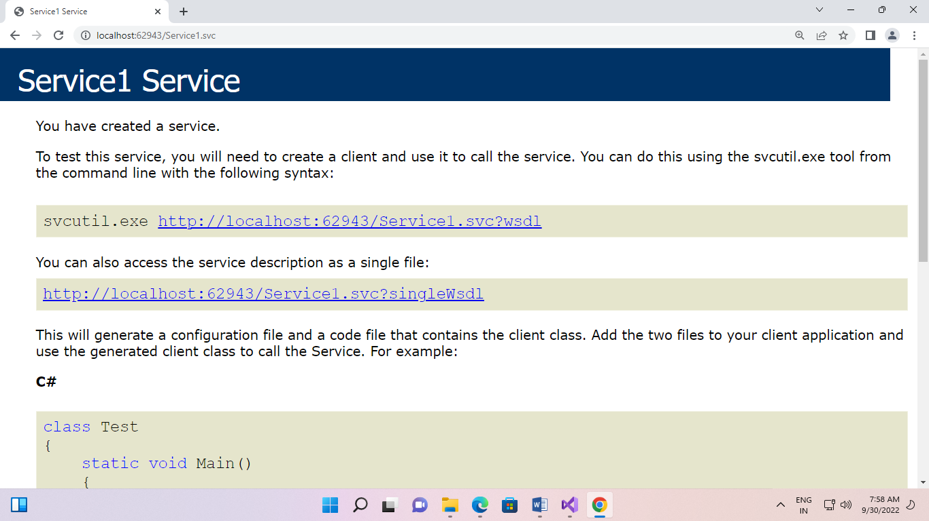

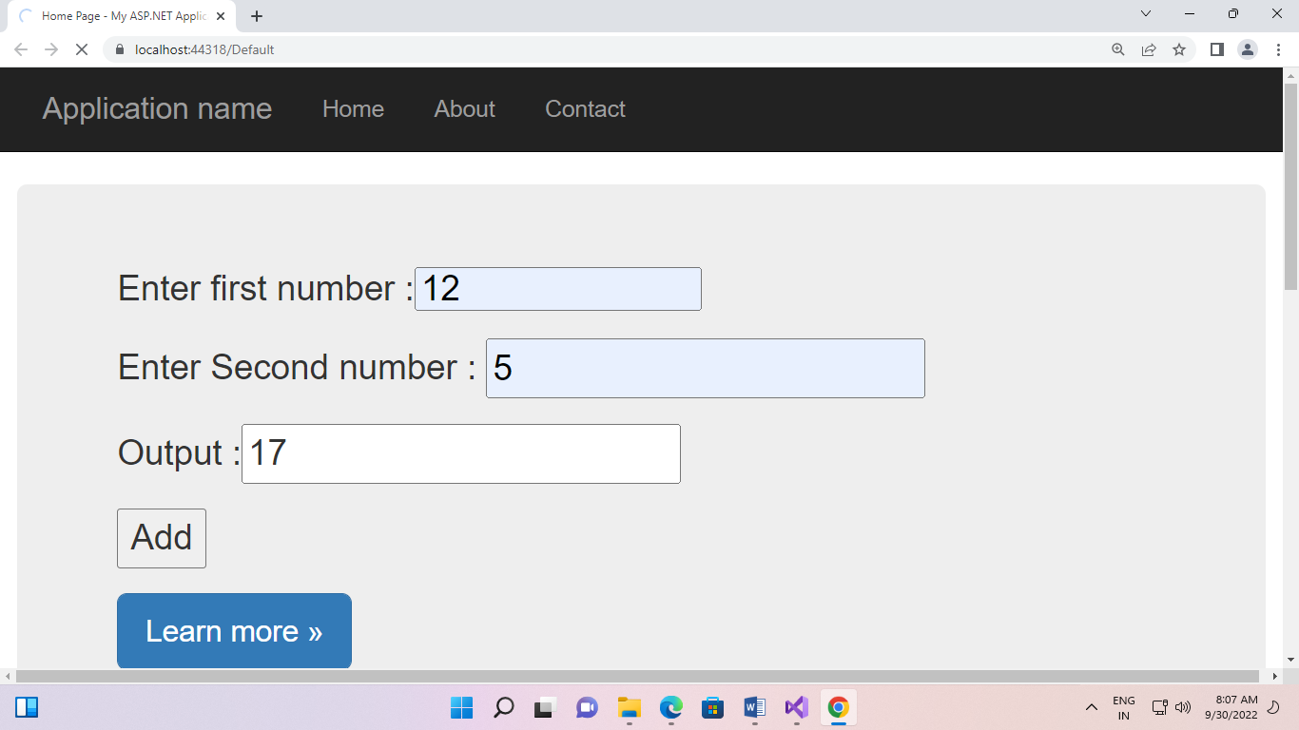

Practical 9:

Aim: Use WCF to create a basic ASP.NET AJAX service.

**Step 1 :**Open Visual Studio 2010.

* Go to File->New->WebSite
* Select ASP.NET Empty WebSite

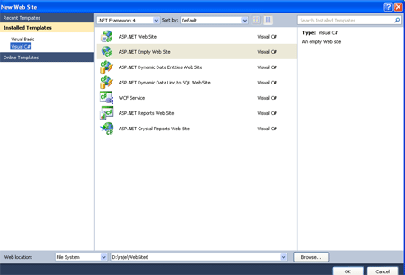

**Step 2 :**Go to Solution Explorer and right-click.

* Select Add->New Item
* Select WebForm
* Default.aspx page open

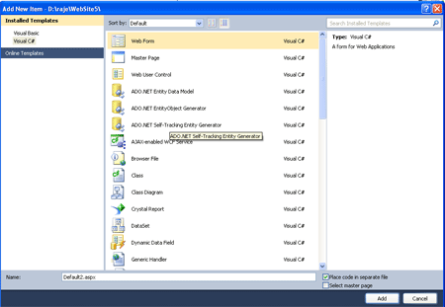

**Define WCF Service :**

**Step 3 :**Go to Solution Explorer and right-click.

* Select Add->New Item
* Select AJAX Enabled WCF Service
* Define the Namespace

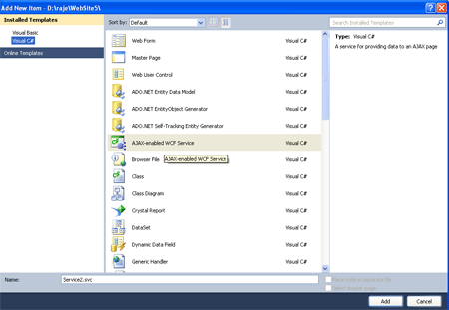

**Namespace :**

[ServiceContract(Namespace = "MCNSOLUTION")]  
[AspNetCompatibilityRequirements(RequirementsMode = AspNetCompatibilityRequirementsMode.Allowed)]  
public class Service  
{  
       // To use HTTP GET, add [WebGet] attribute. (Default ResponseFormat is WebMessageFormat.Json)  
       // To create an operation that returns XML,  
       //     add [WebGet(ResponseFormat=WebMessageFormat.Xml)],  
       //     and include the following line in the operation body:  
       //         WebOperationContext.Current.OutgoingResponse.ContentType = "text/xml";  
       [OperationContract]  
       public void DoWork()  
       {  
              // Add your operation implementation here  
              return;  
       }  
  
**Step 4 :** Open Default.aspx page and click in [Design option].

* Drag and drop Scriptmanager Control

**Define Service Path :**  
**Step 5 :**In [Design] page right-click in Scriptmanager Control

* Select Properties option
* Define Services
* Click the Add option and select Service Path

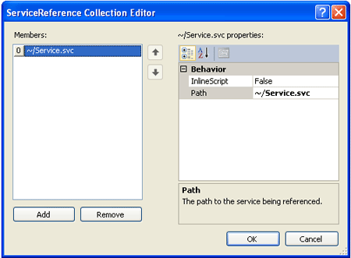

**Step 6 :**Now add a Html Button, an HTML Input box and <Div> to the Deafult.aspx page.After renaming the controls and adding the onClick event of the button, the markup will appear similar to the following:  
  
<div id ="dispService">  
    <input id="btnCallWCF" type="button" value="MCN User" onclick="return btnCallWCF_onclick()"  />  
            <input id="txtUNm" type="text" />

**Java Script code :**  
**Step 7 :**Now go to Default.aspx page and select Design option.

* Click in the input Button
* Define Java Script code for the on click event

**Code :**

<script language="javascript" type="text/javascript">  
        function btnCallWCF_onclick() {  
        }  
    </script>  
</head>  
  
**Step 8 :**Now call the WebService then add the namespace to the service called "MCN Solution".

**Code :**script language="javascript" type="text/javascript">  
        function btnCallWCF_onclick()  
        {  
    var MCN = new MCNSOLUTION.Service();  
    MCN.MCNUSER($get("txtUNm").Value, OnServiceComplete, onerror);  
    }  
function OnServiceComplete(result) {  
    $get("dispService").innerHTML = result;  
    }  
function onerror(result) {  
    alert(result.get_message());  
    }  
</script>

**Add Method :  
  
Step 9 :**Now we add a method called mcnuser which take a user name and return string value.

**Method :**// Add more operations here and mark them with [OperationContract]  
    [OperationContract]  
    public string MCNUSER(string UNAME)  
    {  
        return "HELLOMCN" + UNAME;  
    }  
}  
  
**Step 10 :**Now the complete code for calling the WCF Service in an AJAX Enabled WebService.

**Code :**using System;  
using System.Collections.Generic;  
using System.Linq;  
using System.Runtime.Serialization;  
using System.ServiceModel;  
using System.ServiceModel.Activation;  
using System.ServiceModel.Web;  
using System.Text;  
[ServiceContract(Namespace = "MCNSOLUTION")]  
[AspNetCompatibilityRequirements(RequirementsMode = AspNetCompatibilityRequirementsMode.Allowed)]  
public class Service  
{  
       // To use HTTP GET, add [WebGet] attribute. (Default ResponseFormat is WebMessageFormat.Json)  
       // To create an operation that returns XML,  
       //     add [WebGet(ResponseFormat=WebMessageFormat.Xml)],  
       //     and include the following line in the operation body:  
       //         WebOperationContext.Current.OutgoingResponse.ContentType = "text/xml";  
       [OperationContract]}|  
       public void DoWork()  
       {  
              // Add your operation implementation here  
              return;  
       }  
       // Add more operations here and mark them with [OperationContract]  
    [OperationContract]  
    public string MCNUSER(string UNAME)  
    {  
        return "HELLOMCN" + UNAME;  
    }  
}  
  
**Step 11:**Now run the application by Pressing F5.

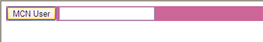

Now click on the MCN USER Button and see the following output.

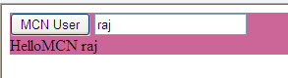

Practical 10:

Aim: Demonstrate using the Binding Attribute of an Endpoint Element in WCF.

**Steps:**

1. **Open Visual studio.**
2. **File>New>Project.**
3. **Select WCF inside C# and WCF class Library.**
4. **Give name as ‘myWCFService’.**
5. **Now open App.Config file and write following code.**

**App.config file**

<?xml version="1.0" encoding="utf-8" ?>

<configuration>

<system.web>

<compilation debug="true" />

</system.web>

<system.serviceModel>

<behaviors>

<serviceBehaviors>

<behavior name="NewBehaviour">

<serviceMetadata />

<serviceDebug includeExceptionDetailInFaults="False" />

</behavior>

</serviceBehaviors>

</behaviors>

<services>

<service name="myWcfService.Service1" behaviorConfiguration="NewBehaviour">

<endpoint address="" binding="netTcpBinding" bindingConfiguration="" name="tcp" contract="myWcfService.IService1"/>

<endpoint address ="mex" binding="mexTcpBinding" name="mextcp" contract="IMetadataExchange"/>

<host>

<baseAddresses>

<add baseAddress="net.tcp://localhost:8081/SampleSrc"/>

</baseAddresses>

</host>

</service>

</services>

</system.serviceModel>

</configuration>

1. Write click on project name and select Clean then Build.
2. Run the project.
3. WCF Test client.
4. Click on getData().
5. Enter any value in Request section and click on invoke.
6. Then you will receive value in Response section.

Output:

